*BidBig*

The open ascending price auction is arguably the most common form of auction in use throughout history. Bidbig have the services of buying and selling goods by offering clients up for bid, taking bids, and then selling the item to the highest bidder.

We have tried creating an online auction site that is user-friendly and robust. It provides user to be an auctioneer or to be a bidder for an auction.

The main features of our platform are-

* Scheduling an auction.
* Start an auction.
* Bid on auction.
* Add an item for auction.
* Add money in wallet.
* Set Product image price description.
* Edit personal information.
* Help users getting best deal for a product.

We have collectively created the various diagrams required to present the flow of working .They are-

1. Flow Diagram.

2. Use Case Diagram.

3. Sequence Diagram.

4. Architecture Diagram.

5. ER Diagram.

***FLOW DIAGRAM***

* LEVEL 1 Flow Diagram

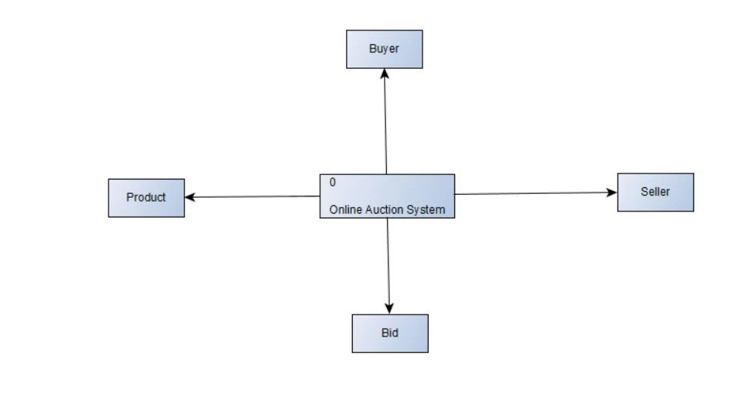

* LEVEL 2 Flow Diagram

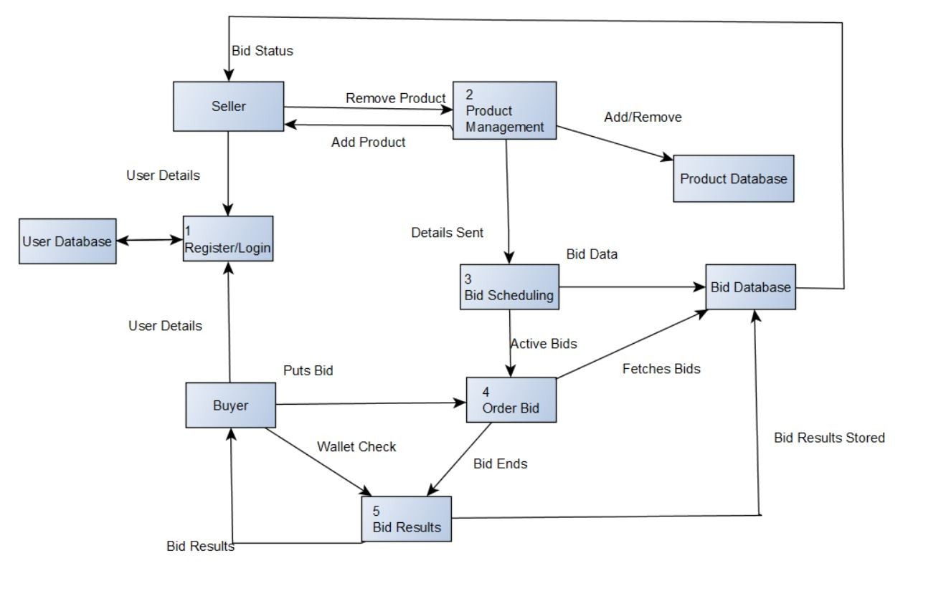

***USE CASE DIAGRAM***

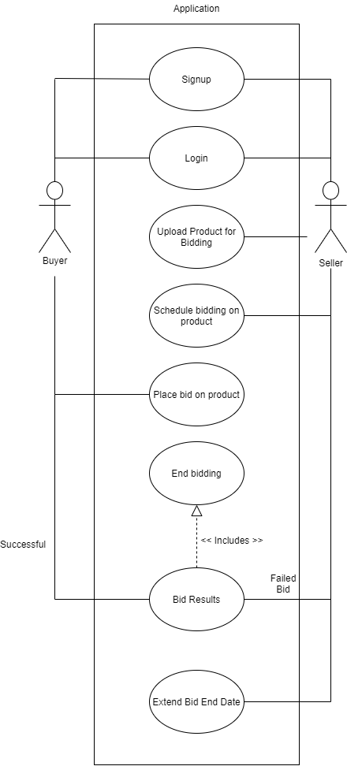

***SEQUENCE DIAGRAM***

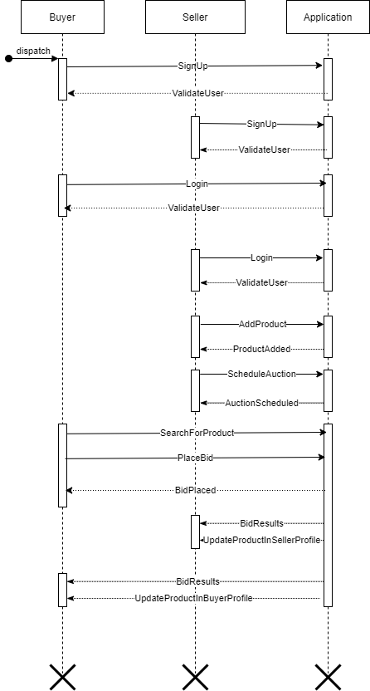

***ARCHITECTURE DIAGRAM***

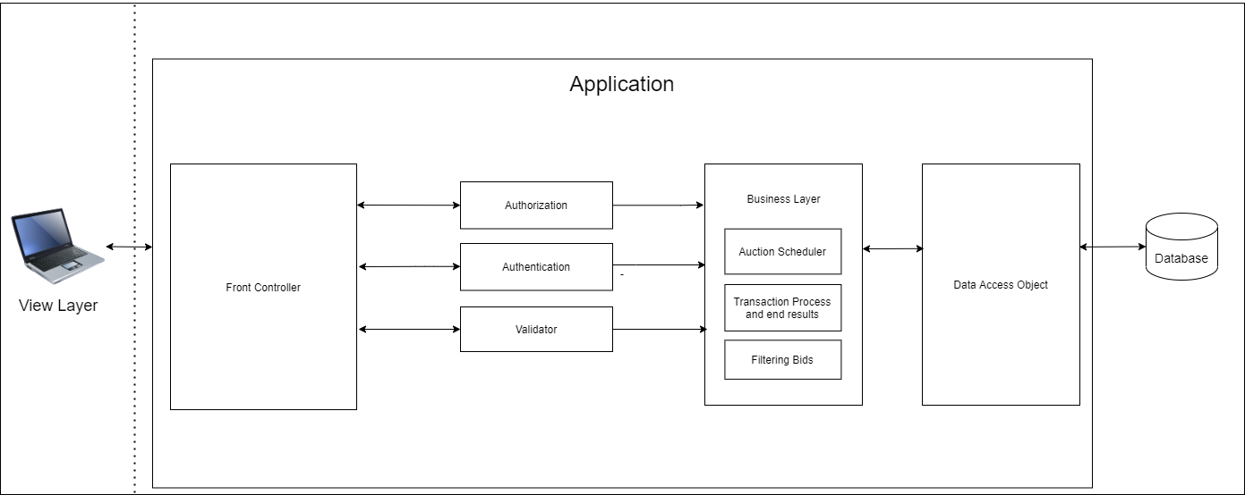

***ER DIAGRAM***

